**PHOTO GALLERY – ASSIGNMENT 3 – SCREEN SHOTS**

1. Open file dialog box window

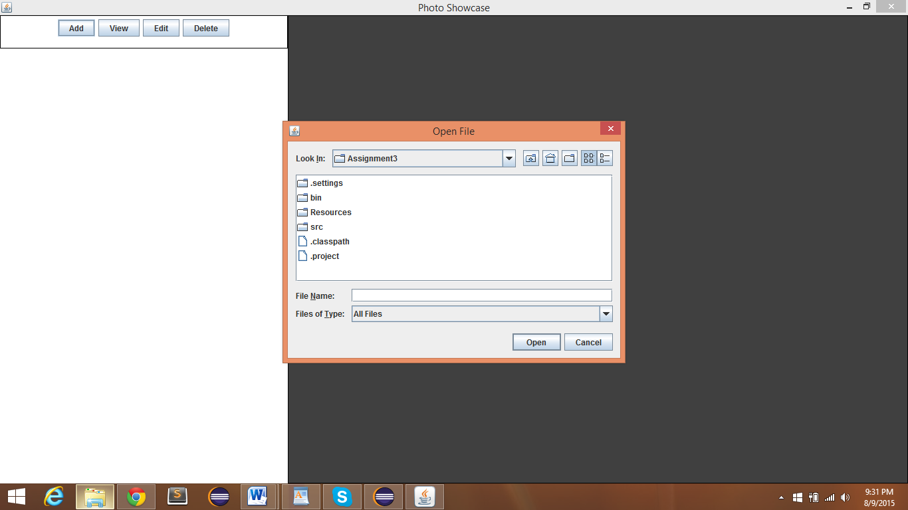

1. Add photos panel

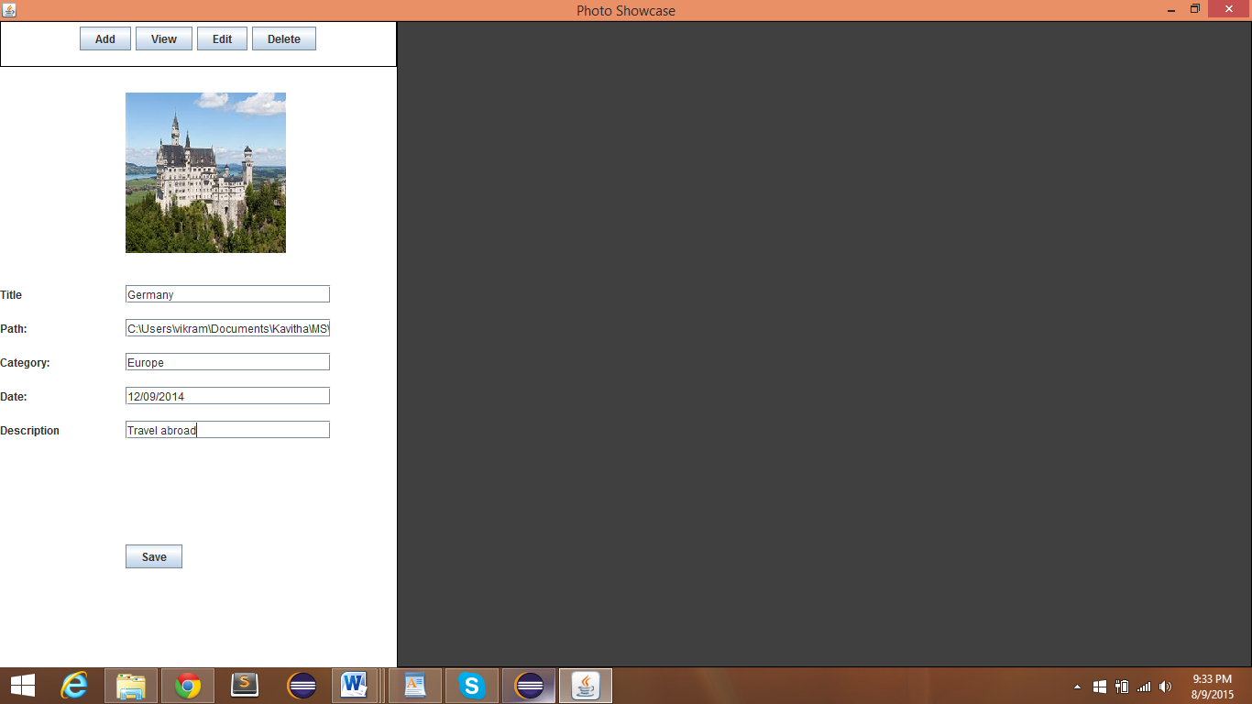

1. Photo gallery

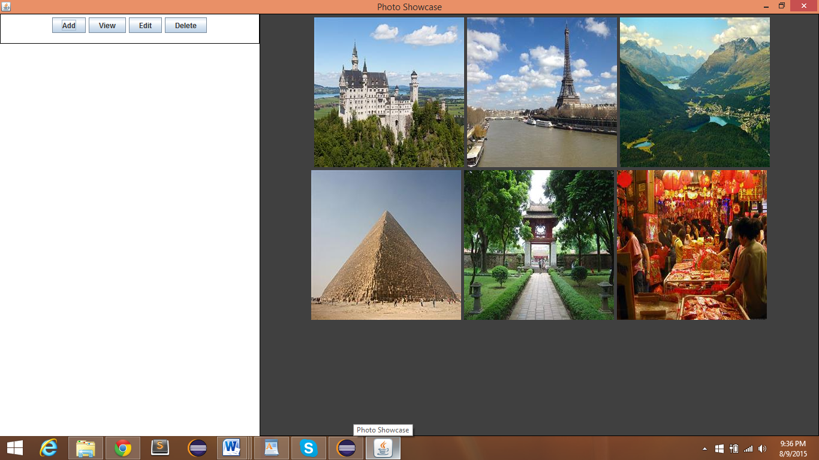

1. View by Category

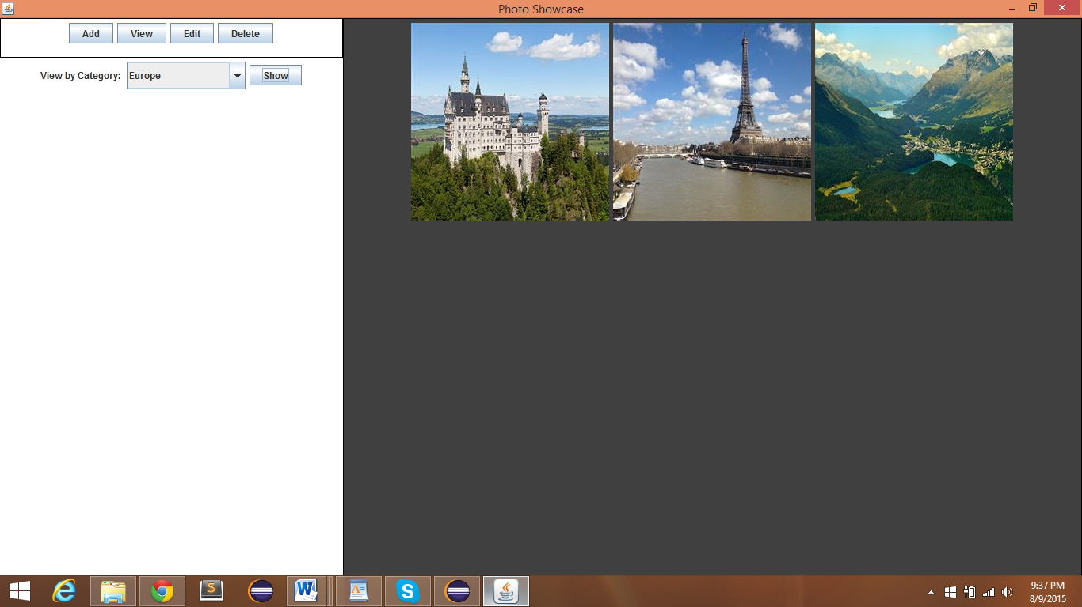

3)Edit pictures panel

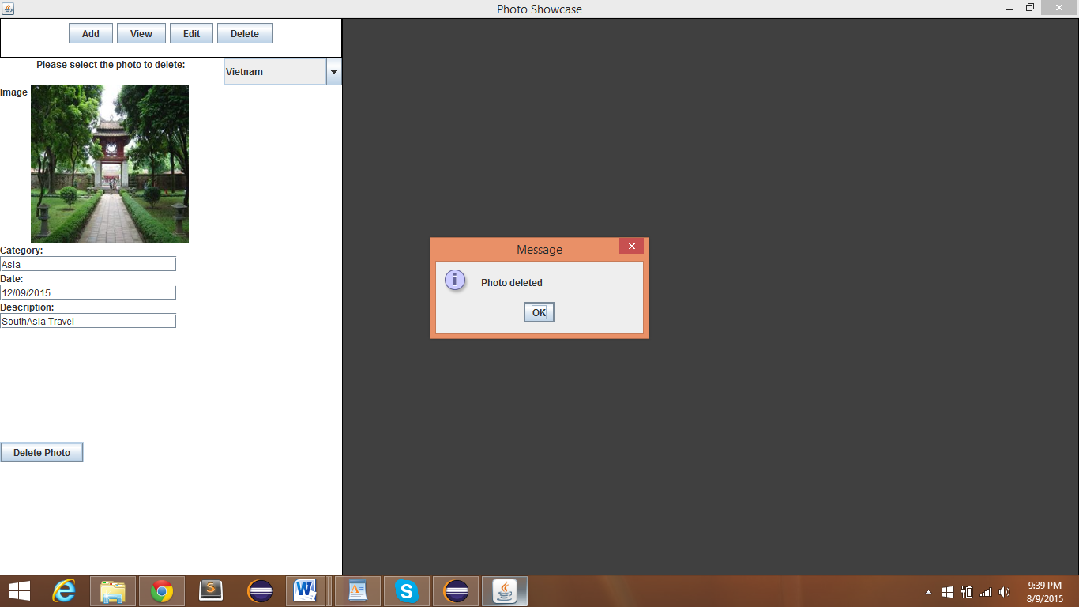

1. Delete pictures panel

